

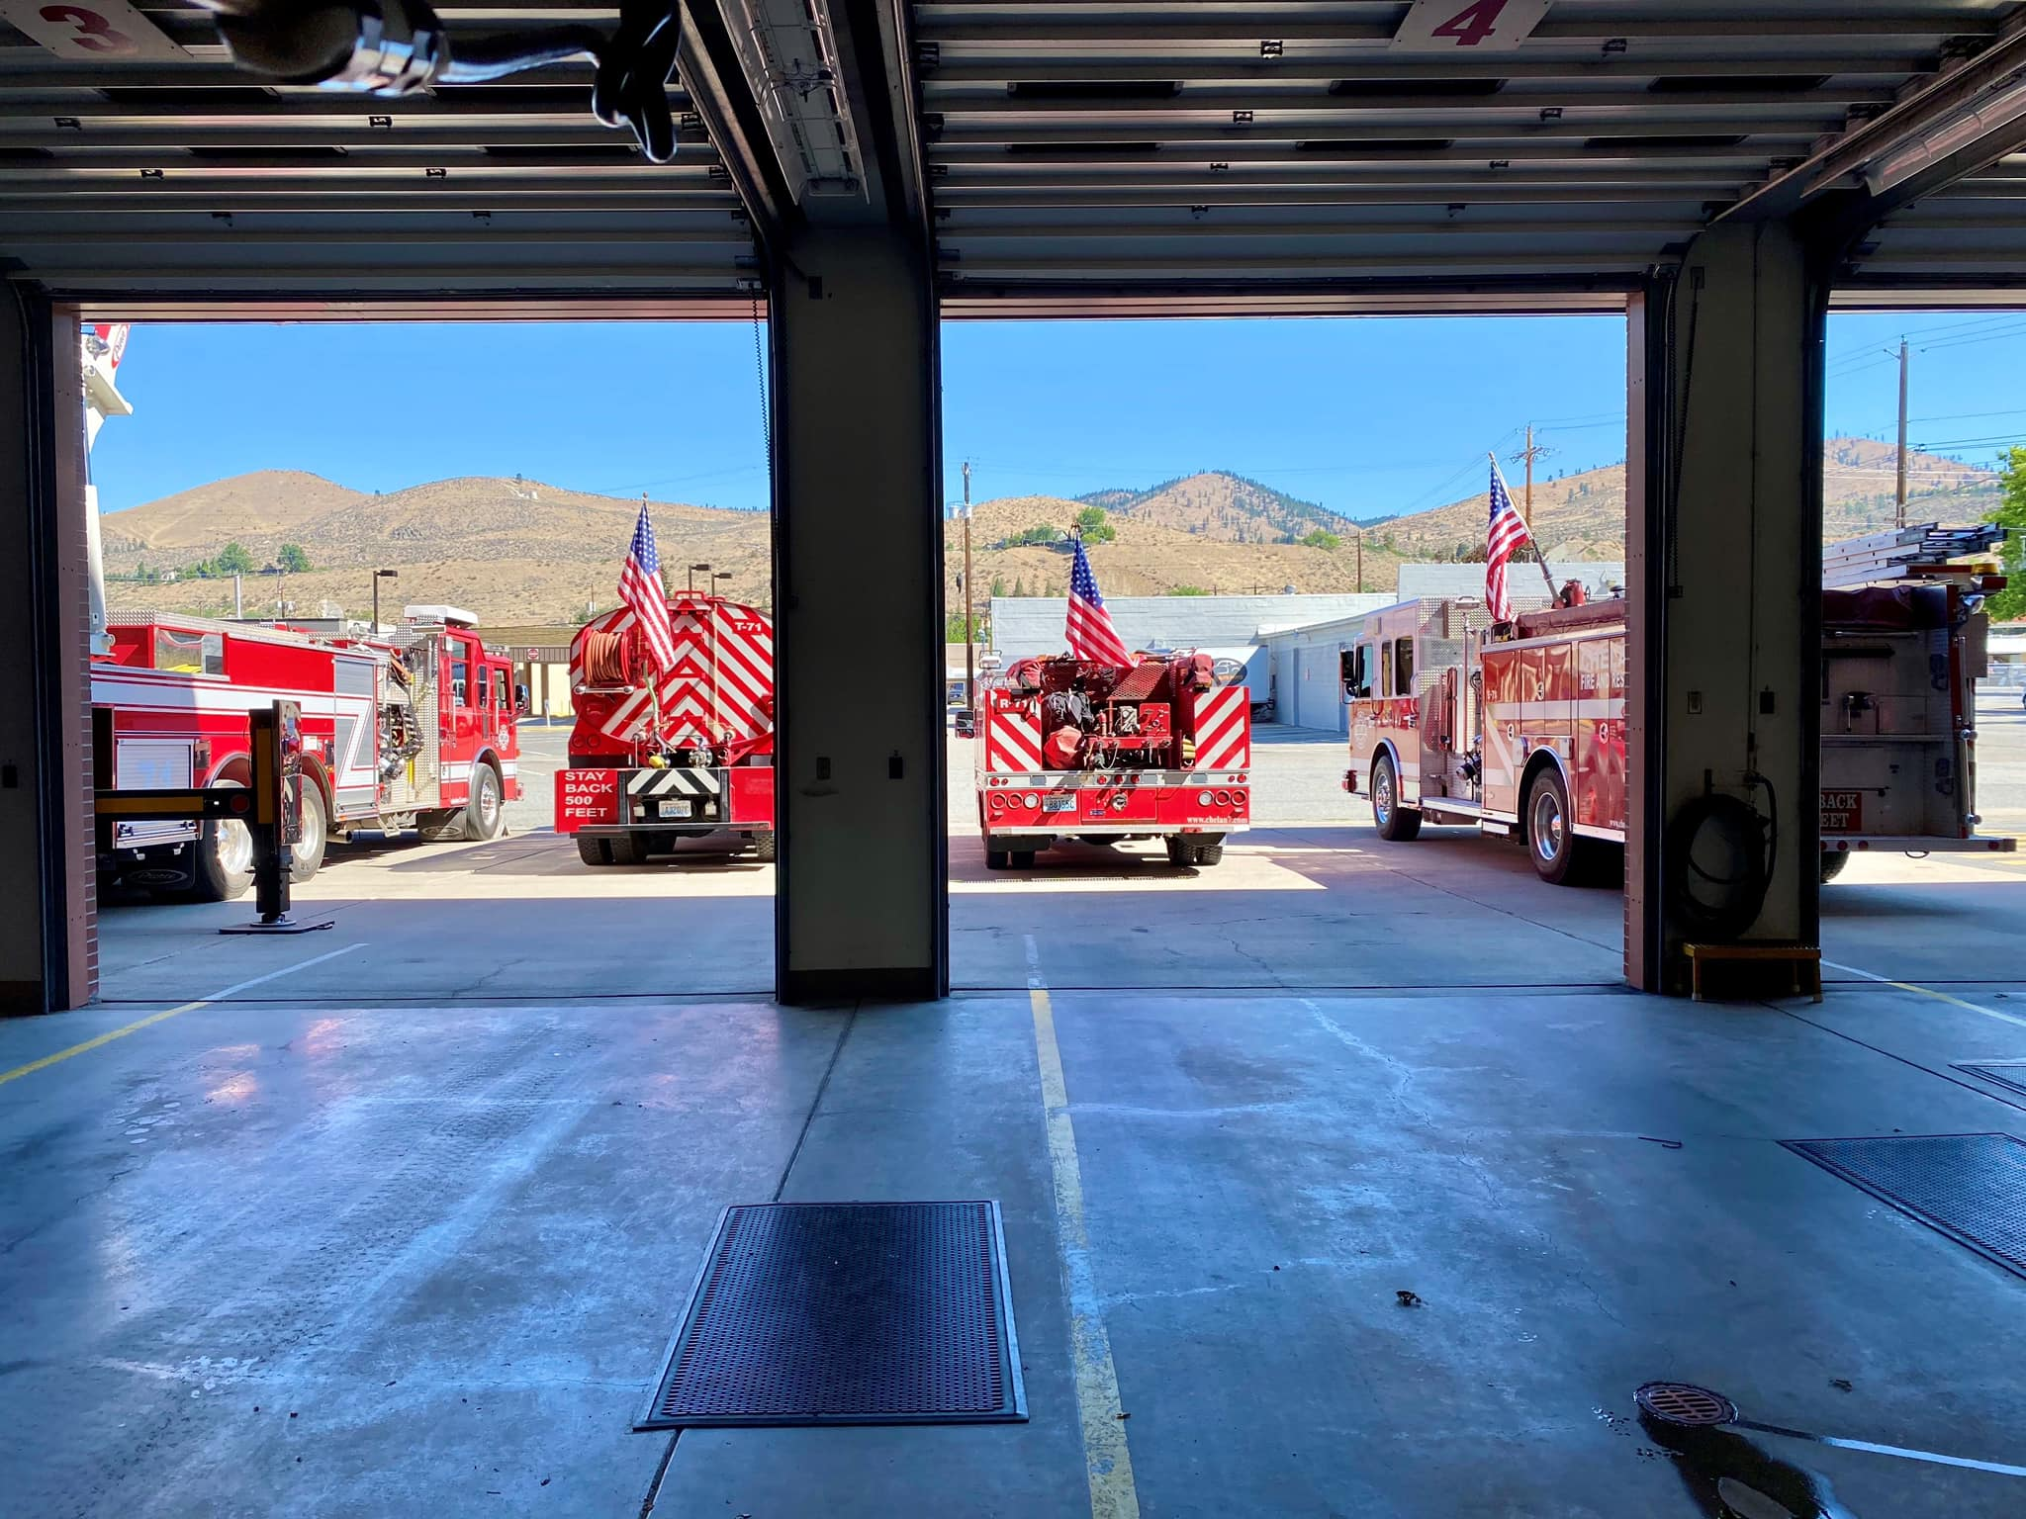**CHELAN FIRE, RESCUE & EMS**

**2020**

**ANNUAL REPORT**

**________________________________________________**

***Chief’s Message***

**________________________________________________**

As Fire Chief of Chelan Fire & Rescue, I am proud to present to you our 2020 Annual Report. This Annual Report provides our community an overview of Chelan Fire & Rescue and our accomplishments and challenges that we have faced together throughout this year.

2020 marked the first full year of my tenure as Fire Chief and to say that it was not challenging is an understatement. The COVID-19 pandemic placed tremendous pressure on our organization not only in the delivery of emergency services but also our ability to prepare and manage a serious issue that has had a tremendous impact on our community. Through the commitment of our personnel to stay true to our mission, we have been able to rise-up and work together with many of our partner agencies. Together we have met those challenges, keeping our community safe and healthy. We still have much work to do, but we know that together we will get through this.

Operationally, Chelan Fire & Rescue responded to 929 calls for emergency service in addition to participating in numerous state mobilizations throughout Washington and California. We faced our own major fire challenge on September 7th with the Apple Acres Fire that required statewide assistance to mitigate. This fire was just one of many that plagued Washington State that day leading to the largest single day fire loss in our state’s history.

Even with these challenges we were able to develop and adopt our 2021 -2025 Strategic Plan which we be our guiding document for moving Chelan Fire & Rescue into the future. The foundation of this plan was developed through an internal SWOT Analysis that surveyed our members to help in identifying our strengths and weakness, as well as looking for opportunities and threats. We have approved our 2021 Operating Budget that has incorporated sound financial practices to ensure the community that we are good stewards of the community resources. Chelan Fire & Rescue ended 2020 with our operational finances coming in under budget at 99% spent and an increased carry-over for 2021 in the amount for $703,000.00. Our Annual Report highlights many of the accomplishments that we have been able to achieve through effective and transparent financial responsibility.

All our successes in accomplishing our achievements and meeting the challenges that we faced could not have been possible without our most important asset, our members. Our members from those serving in the reserve and career ranks to our administrative personnel, Board of Commissioners, and Firefighters Association, pulled together to stay focused on our mission: to enhance the quality of life and safety of our community through emergency response, education, and prevention. I am proud to work side by side with each and every member of Chelan Fire & Rescue each and every day. I am deeply humbled and honored to be part of this incredible fire family and their commitment to this community.

Mark R. Donnell

Fire Chief

______________________________­­______________________________________________

***Mission Statement, Vison Statement, Core Values***

____________________________________________________________________________

**MISSION STATEMENT**

Our mission is to enhance the quality of life and safety of our community by protecting lives and property through emergency response, education and prevention.

**VISION STATEMENT**

To provide quality emergency response to our growing community while responsibly developing a new future that actively focuses on creating efficiencies, professional accountability, effective training of our members, use of emerging technologies, and fiscal sustainability.

**CORE VALUES**

* **Professionalism** – showing love for the job by acting with pride, ownership,

and passion

* **Respect** – for our co-workers, ourselves, and especially our community

members

* **Integrity** – demonstrating ethical and moral character in all of our actions
* **Dedication** – being committed to the mission, values, and core values
* **Empathy** – having compassion for one another and those we serve

**________________________________________________**

***2020 INCIDENT STATISTICS***

**________________________________________________**

In 2020 we responded to 929 calls for emergency service which was an increase of 6.4% over our 2019 call volume. Even though the majority of our emergency responses were for rescue and emergency medical incidents, our calls for fire suppression average higher than most fire response agencies due to our Wildland Urban Interface. On September 7th, Chelan Fire & Rescue personnel were involved not only with the Apple Acres Fire (6,000 acres) within our own fire district but also on the initial attack for the Pearl Hill Fire (224,000 acres within Okanogan & Douglas counties.) The 2020 Washington Labor Day Fires, precipitated by high winds and dry conditions, burned more than 330,000 acres across the state resulting in the greatest single day fire loss in the past 12 fire seasons.

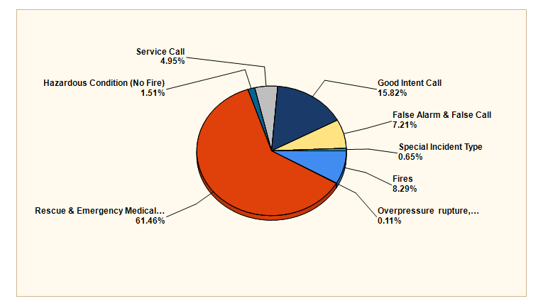

|  |  |  |
| --- | --- | --- |
| **MAJOR INCIDENT TYPE** | **# INCIDENTS** | **% of TOTAL** |
| Fires | 77 | 8.29% |
| Overpressure, rupture, explosion (No Fire) | 1 | .11% |
| Rescue & Emergency Medical Service | 571 | 61.46% |
| Hazardous Condition (No Fire) | 14 | 1.51% |
| Service Call | 46 | 4.95% |
| Good Intent Call | 147 | 15.82% |
| False Alarm & False Call | 67 | 7.21% |
| Special Incident Call | 6 | .65% |
| **TOTAL** | 929 | 100.00% |

**2020 Incidents by Month**

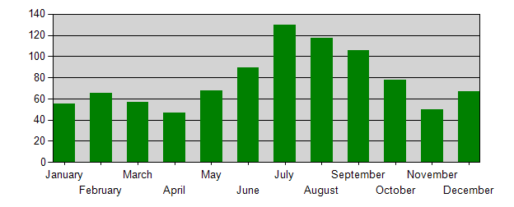

**2020 Incidents by Day of Week**

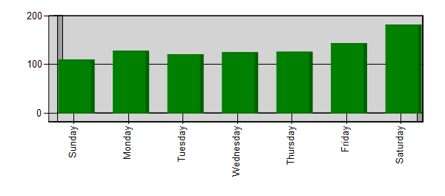

**2020 Incidents by Hour of Day**

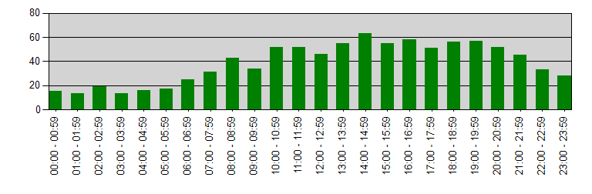

**________________________________________________**

***2020 turnout times and responses***

**________________________________________________**

Chelan Fire & Rescue has established Response Time Standards that are outlined in Standard Operating Guideline (SOG) 010, Service Goals and Objectives. The service goals and objectives are adapted from NFPA 1710 and NFPA 1720 Standards for the Organization and Deployment of Fire Suppression. EMS, and Special Operations to the Public by Career and Volunteer Fire Departments.

Turnout (Reaction) Time is period of time when responders are notified by dispatch and the beginning of movement towards the emergency incident. Turnout Time Standards are identified in SOG 010, Service Goals and Objectives, and are listed below. Stations meeting Turnout Time Standard for 2020 are indicated in bold.

|  |  |
| --- | --- |
| **2020 Turnout Times by Station** | **Turnout Time (min)** |
| 71 - City of Chelan (2 minutes) | 3:31* |
| 72 - Chelan Falls (10 minutes) | **7:04** |
| 73 - Union Valley (10 minutes) | 16:16 |
| 74 - Howard Flats, Chelan Airport (10 minutes) | 12:48 |
| 75 - South Lakeshore (10 minutes) | **7:59** |
| 76 - North Shore (2 minutes) | **1:54** |
| 77 - Bear Mountain, Hawks Meadow, Pat & Mikes (2 minutes) | 4:49 |
| CC - Chelan County (Mutual Aid Response) | 8:50 |
| DC - Douglas County (Mutual Aid Response) | 11:19 |
|  |  |

Response Time is a combination of turnout time and travel time to the incident. Response Time

Standards are identified in SOG 010, Service Goals and Objectives, and are listed below. The Response Time Standard is a 90 Percentile Time meaning that we are able to arrive to 90% of emergency incidents. Stations meeting Response Time standard for 2020 are indicated in bold.

|  |  |
| --- | --- |
| **2020 Response Times by Station** | **Response Time (Min)** |
| 71 - City of Chelan (5 minutes) | 7:34* |
| 72 - Chelan Falls (10 minutes) | 13:21 |
| 73 - Union Valley (20 minutes) | **12:55** |
| 74 - Howard Flats, Chelan Airport (20 minutes) | **15:24** |
| 75 - South Lakeshore (22 minutes) | **17:51** |
| 76 - North Shore (15 minutes) | **10:23** |
| 77 - Bear Mountain, Hawks Meadow, Pat & Mikes (15 minutes) | **12:57** |
| CC - Chelan County | 22:45 |
| DC - Douglas County | 42:08 |

*Station 71 has both 24/7 career personnel staffing with reserve members responding from home which impacts average turnout and response times. Career staff turnout and response times were consistently within the 90 Percentile Time Standard for 2020.

**________________________________________________**

***2020 effective work force***

**________________________________________________**

The Effective Work Force is the number of personnel necessary to complete critical tasks as outlined for specific emergency responses. Those numbers are identified in SOG 010, Service Goals and Objectives, and are listed below. Effective Workforce numbers in BOLD met standard for 2020.

|  |  |
| --- | --- |
| **2020 Effective Work Force (Minimum)** | **Personnel** |
| Emergency Medical Responses – BLS (2) | **2** |
| Wildland Fire Responses (4) | **10** |
| Residential Fire Responses – 1st Alarm (11) | 8 |
| Residential Fire Responses – 2nd Alarm (17) | 11 |
| Commercial Fire Responses – 1st Alarm (16) | 8 |
| Commercial Fire Responses – 2nd Alarm (24) | 15 |
| Vehicle Fires (4) | **5** |
| Hazardous Materials Incidents (3) | **3** |
| Technical Rescue – Low Angle & Water (5) | **8** |

**_______________________________________________________________**

***2020 pre-fire property values VS. FIRE LOSS***

**________________________________________________________________**

Pre-Fire Property Values Versus Fire Loss validates agency ability to respond quickly to safely and effectively prevent property loss. Any value loss has a direct impact on the economics of a community and our continued ability to provide emergency operations due to loss assessed property valuation.

|  |  |  |  |
| --- | --- | --- | --- |
| **INCIDENT #** | **PRE-INCIDENT VALUE** | **LOSSES** | **SAVED** |
| 2020-12 | $1,700,000.00 | $0.00 | $1,700,000.00 |
| 2020-30 | $3,070,000.00 | $320,000.00 | $2,750,000.00 |
| 2020-36 | $5,500.00 | $5,500.00 | $0.00 |
| 2020-126 | $2,500.00 | $2,500.00 | $0.00 |
| 2020-194 | $69,000.00 | $25,000.00 | $44,000.00 |
| 2020-203 | $555,706.00 | $0.00 | $555,706.00 |
| 2020-297 | $618,278.00 | $618,278.00 | $0.00 |
| 2020-318 | $707,632.00 | $707,632.00 | $0.00 |
| 2020-570 | $112,925.00 | $17,000.00 | $95,925.00 |
| 2020-866 | $5,000.00 | $5,000.00 | $0.00 |
| 2020-869 | $7,556.00 | $7,556.00 | $0.00 |
| 2020-894 | $150,557.00 | $1,000.00 | $149,557.00 |
| 2020-898 | $53,650.00 | $1,400.00 | $52,250.00 |
| **Totals:** | **$7,058,304.00** | **$1,710,866.00** | **$5,347,438.00** |

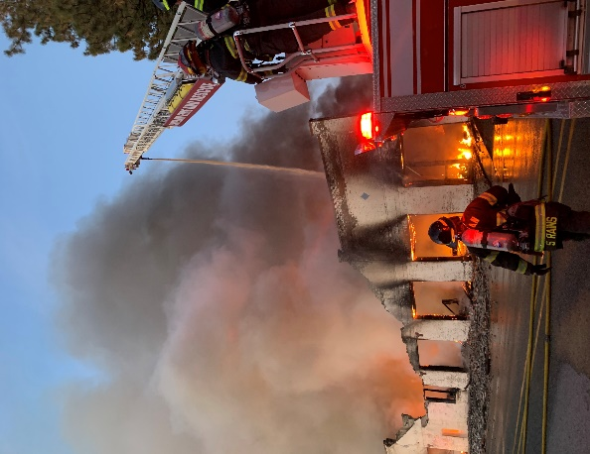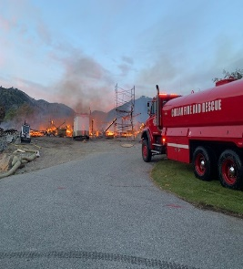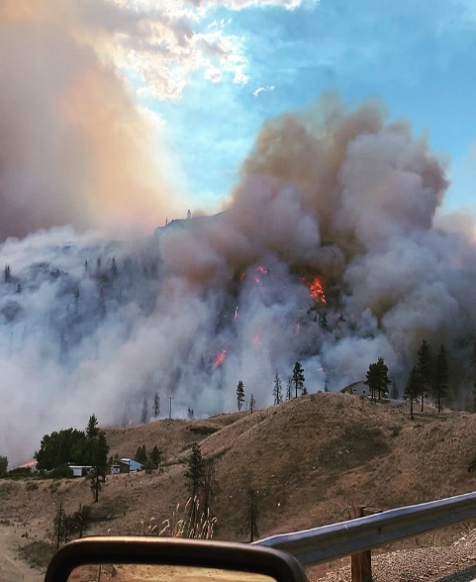

**_______________________________________________**

***2020 PERSONNEL AND TRAINING***

**________________________________________________**

Chelan Fire & Rescue was able to maintain adequate staffing throughout most of 2020 with 7 career personnel, 2 seasonal firefighters, stipend program participants, and our Reserve Fire Personnel. Recruitment efforts were challenged during this pandemic period due to onset of infection control restrictions which impacted our ability to interact with our community for successful recruitment. Despite these issues, Chelan Fire & Rescue was able to assist with the many mutual aid and state mobilization requests during a difficult 2020 wildfire season in addition to protecting our own district from the Apple Acres Fire. At the end of 2020, Chelan Fire & Rescue membership included:

* 3 Commissioners
* Administrative Office Manager
* Administrative Office Assistant
* Fire Mechanic
* Fire Chaplain
* Fire Chief
* Assistant Chief – Volunteer Recruitment & Retention(Grant funded through 2021)
* 3 Career Fire Captain/EMTs
* 4 Career Firefighter/EMTs
* 35 Reserve Members (33 wildland qualified, 22 structure qualified, 6 certified EMTs)
* 2 Marine Operators

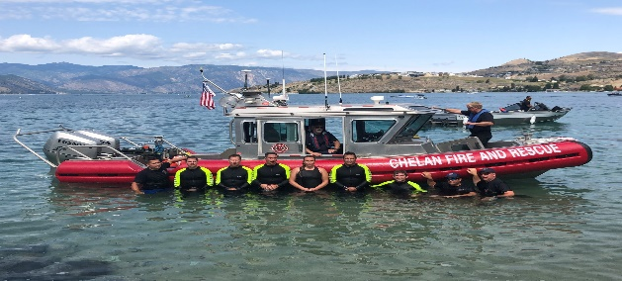

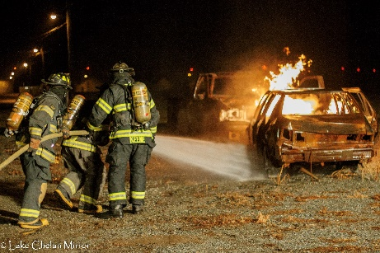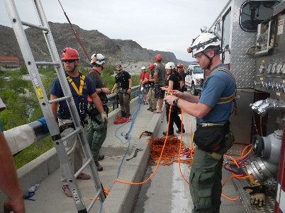

Keeping our members proficient in the skill set necessary for safe and effective firefighting was a challenge with the onset of Covid in late February. Our members manage to accumulate over 4300 hours training through a combination of drill participation and online training to meet those annual requirements. Annual training included:

* Live Fire & Fire Suppression
* Initial and Annual Wildland Refresher Training
* EMS
* Annual Rapid Entry Rescue Swimmer & Marine-71 Operator programs
* Technical Rescue – Low Angle Rope Rescue
* Hazmat Operations
* Annual EVIP and Driver/Operator Training
* Blue Card Incident Command

**________________________________________________**

***2020 APPARATUS***

**________________________________________________**

Historically, apparatus replacement has been a challenge for Chelan Fire & Rescue due to budget constraints but significant progress was made this past in the acquisition of replacement apparatus.

* We surplussed two aging (> 25 years-old) Type 1 Structure engines, as well as a 30-year-old Tender, that have found service within our own community or another agency that could use them.
* We acquire a military surplus M-1083 at no cost through DNR Apparatus Program and convert it into a Type 3 Heavy Brush Truck with funding assistance through the DNR Phase 2 Grant program. This apparatus will give us a service life of 10+ years at a cost of $35,000.00 to the Fire District.
* We replaced a chassis on one of our Type 6 Brush Trucks with an upgraded Dodge 5500 chassis.
* We purchase a 2003 HW Spartan Type 1 Structure Engine that was surplussed from the City of Bellevue.
* These acquisitions added a 4th structure Engine and 3rd Type 3 Heavy Brush Truck to upgrade our aging fleet with apparatus with a service life of 10+ years at a cost of $70,000.00.
* With no clear path to forecast future apparatus replacement, staff developed an Apparatus Replacement Schedule that helps us in forecasting future apparatus replacement cost.
* On the negative side, Ladder-71, (2007 Pierce 75” Quint) which was purchased in 2019, failed its annual UL testing due to significant corrosion issues. We are currently working on correcting these issues in order to place this essential fire apparatus back into service.

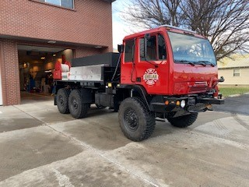

Brush Truck 7-703 - Heavy

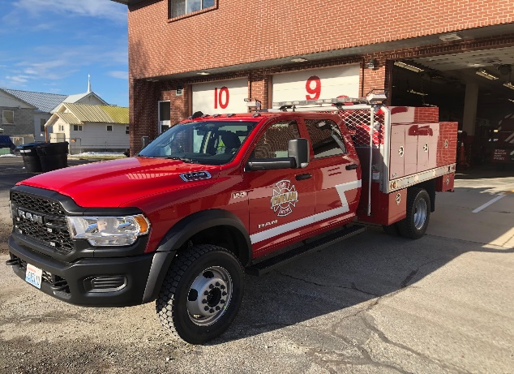

Brush Truck 7-701 Dodge RAM

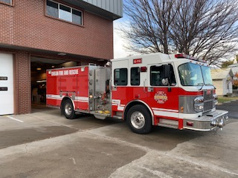

Structure Engine 7-403

Structure Engine 7-403 Spartan

**________________________________________________**

***2020 FACILITIES & CAPITAL PROJECTS***

**________________________________________________**

Chelan Fire & Rescue completed a number of facility projects in addition to acquiring new and much needed equipment in 2020. Priorities for 2020 included dorm room improvements, emergency generator and heating systems, training facility props, and equipment replacement. Due to Covid, some projects have been delayed into 2021. Some projects required using contractors to complete the work while others we have been able to complete with duty staffing that help with overall project costs. As with our apparatus Replacement Schedule, staff developed a Capital Replacement Schedule that will enable us to forecast and budget future facility improvements and equipment needs.

**Facilities:**

* Painted dorm rooms at Station 71 (duty crew project)
* Restriped apparatus bays (duty crew project)
* Repainted numbers on overhead bay doors at Station 71 (duty crew project)
* Completed domestic water service project at Station 73
* Placed steel barricades at Station 73 to prevent cistern pump damage
* Replacement of outdated lighting at Station 74 at no cost to District (2021 completion.)
* Emergency Generator for Station 74 secured through FMAG program (2021 completion)
* Place additional propane props in service at Station 74
* Replaced heating system at Station 75
* Lock changeout and security improvements at all Fire District Facilities

**Equipment:**

* Slip tank (100 gal) with pump placed on Chief 71.
* Replacement of hose and appliances necessary for fire suppression.
* Replacement of outdated Automated External Defibrillators.
* Replacement of structural and wildland personal protective gear.
* Replacement of radios and pagers.
* Equipment for chainsaw chain sharpening and building.
* New scan tool for Fleet Manager
* New personal fitness equipment

**____________________________________________________________**

***2020 CHELAN FIRE AND RESCUE HIGHLIGHTS***

**_____________________________________________________________**

**Strategic Planning & Budget:**

* 2021-2025 Strategic Plan Developed and Adopted
* 2020 Budget (Year-end budget spent @ 99% of forecast)
* 2021 Budget Process and Approval
* 2020 Internal SWOT Analysis
* 2020 State & Federal Audits

**Operations and Incident Response:**

* Covid Pandemic Response
* 2020 Call Volume @ 929 calls (increase of 6.4% over last year)
* State and California Mobilizations
* Major Incidents: Apple Acres & Pearl Hill Fires (September 7, 2020)
* Assisted on multiple 2nd and 3rd alarm fires in Chelan and Douglas Counties

**Apparatus:**

* B-74H Build (M-1083)
* Replacement of 1st Ford 550 Chassis with Dodge 5500 Crew Cab (R-71)
* Purchase of 2003 Spartan Type 1 Engine (E-79)
* Surplus sales of 2 engines and 1 tender
* L-71 UL certification failure
* Added slip-in tank/pump to C-71

**Facilities:**

* Painted dorm rooms at Station 71 (duty crew project)
* Restriped apparatus bays (duty crew project)
* Repainted numbers on overhead bay doors at Station 71 (duty crew project)
* Completed domestic water service project at Station 73
* Placed steel barricades at Station 73 to prevent cistern pump damage
* Replacement of outdated lighting at Station 74 at no cost to District (2021 completion.)
* Emergency Generator for Station 74 secured through FMAG program (2021 completion)
* Place additional propane props in service at Station 74
* Replaced heating system at Station 75

**Other:**

* Firefighters Association Successes despite Covid
* Completed 2017 Annexations
* 2019 Awards Banquet – February 2020

**____________________________________________________________**

**2020 Chelan Firefighters Association**

**____________________________________________________________**

The Chelan Firefighters Association is an integral part of our organization that focuses on benevolent efforts to our community. This incredible organization, comprised of current and former members as well in addition to members of the community, provides emergency funds for the victims of fires and accidents in their most desperate time of need. Through their annual fundraising efforts, they contribute to local food programs, sponsorships of community programs, support of our veterans at their annual parade, and ensuring that Parade 71 is out and about in the community. This organization has been instrumental in providing the community with our newest rescue resource: Marine 71. Their unselfish efforts have provided our community with much need resources all in support of our mission.

Even though the 2020 Covid pandemic postponed a number of community events that this organization utilizes for fundraising, the Firefighters Association has still been active in achieving a remarkable list of accomplishments for the year. We are proud to have the Chelan Firefighters Association as part of our organization.

**Chelan Fire Fighters Association Accomplishments 2020:**

* Enlisted the shop class at Chelan High School to build for us a secure shed to house all Association equipment at Station 71, freeing our shift personnel from needing to transport equipment from Station 74
* Donated $3,000 to Thrive Chelan Valley to help feed schoolchildren during the pandemic
* Donated $5,000 to Okanogan Long-Term Recovery Group to help victims of the Pearl Hill Fire
* Donated $1,000 to Chelan Valley Hope to help victims of the Apple Acres Fire
* Donated $1,000 to the GoFundMe Account for the parents of a 3-year-old boy who perished in the fires up north
* Maintained quarterly $500 payments to Chelan Food Bank
* Donated $1,000 to Chelan Food Bank to help supply holiday dinners to needy families
* Purchased $400 worth of Halloween candy for local kids
* Donated $500 to the Chelan VFW Association for veterans’ luncheons on Veterans Day
* Donated $500 to support “Santa’s Stars” gift purchases for local kids
* Purchased new electronic equipment for Marine-71
* Purchased new safety equipment for Marine-71
* Purchased a new voltage invertor and alternator for the Parade Truck

**2020 Budget and Financials**

Chelan Fire & Rescue closed out 2020 with increased revenues, generated through state mobilization reimbursements, and deceased operating expenses that resulted in an increase in uncommitted funds. Our sound financial management practices along with annual state/federal audits demonstrate our commitment to financial stewardship of the funds we are entrusted.

**2020 2020 Actual**

Starting Fund: $ 600,000.00 $ 539,489.79

Tax Revenue: $2,114,207.49 $2,153,097.37

SAFER Grant; $ 227,129.00 $ 284.653.00

Other Revenue: $ 13,480.00 $ 169,231.37

Transfer In $ 0.00 $ 18,248.00

Sub-Total: $2,954,816.49 $3,172,831.62

Expenses: $2,029,241.00 $2,004,013.08

Transfer to Capital $ 102,000.00 $ 108,461.00

To General Reserve Investment $ 76,200.00 $ 76,200.00

To Capital Reserve Investment $ 0.00 $ 8,220.00

Transfer Out Bond $ 90,400.00 $ 88,900.00

Sub-Total $2,287,202.00 $2,312,277.00

Ending Balance: $ 641,070.28 $ 703,033.75

Desired Carry Over: $ 600,000.00 $ 600,000.00

Uncommitted Funds $ 64,134.00 $ 103,033.75

**General Reserve Investment Fund**

General Reserve Investments cover contingency expenses, meet seasonal cash flow shortages, and upgrade or maintain the Fire District’s credit rating. 2020 through 2022 budgets will allocate $76,200.00 annually to this account to bring the District into compliance with our internal financial policies.

2020 Year End Account Balance $632,859.02

**Capital Reserve Investment Fund**

The Capital Reserve Investments are funds allocated for apparatus replacement and capital expenses. Funds from this account were used for apparatus replacement that is identified under the 2020 Apparatus section and Capital Projects identified in our 2020 Budget. This account is funded through reimbursements received from state mobilizations, sales of surplus apparatus and equipment, and any uncommitted funds at year end as approved by the Board of Commissioners.

2020 Year End Account Balance $164,746.48

**Chelan Fire, Rescue & EMS**

***Administration Office***

***232 E. Wapato Ave.***

***PO BOX 1317***

***Chelan, WA, 98816***

***Mark Donnell***

***Fire Chief***

[*mdonnell@cfr7.org*](mailto:mdonnell@cfr7.org)

***Brandon Asher***

***Assistant Fire Chief/Volunteer Coordinator***

[*basher@cfr7.org*](mailto:basher@cfr7.org)

***Carol Kibler***

***Administrative Office Manager***

[*carolk@cfr7.org*](mailto:carolk@cfr7.org)

**Website: Chelan7.com**