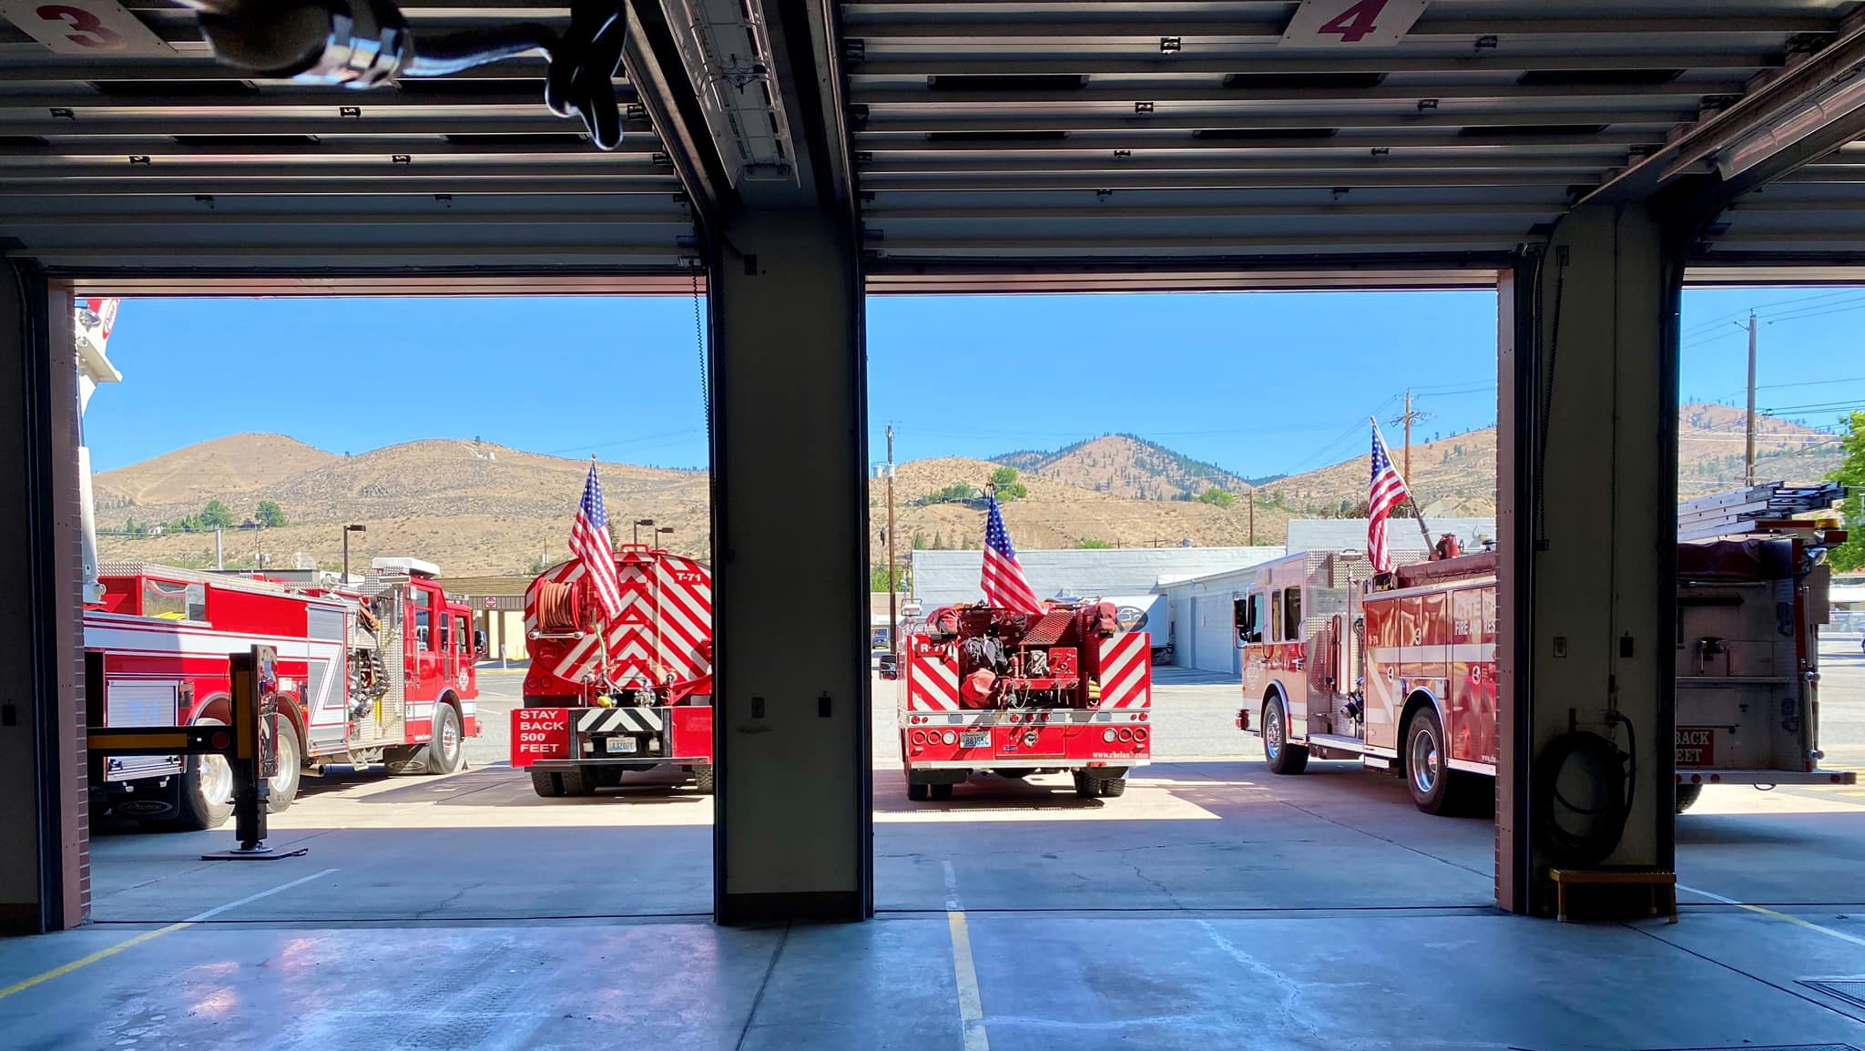
CHELAN FIRE, RESCUE, & EMS

2021
ANNUAL REPORT

________________________________________________

Chief’s Message
________________________________________________

On behalf of all members of Chelan Fire & Rescue, I am pleased to present our 2021 Annual Report. Our Annual Report provides our community with an overview of Chelan Fire & Rescue, highlighting our accomplishments and the challenges that we have faced together in 2021.

2021 will mark my final year in the fire service and I am proud knowing that Chelan Fire & Rescue is in a better position for its future successes. The voter approval of Proposition 1, ensures that the members of Chelan Fire & Rescue will be able to continue to fulfill our mission by providing the personnel, equipment, and facilities for today and into the future. With the commitment of our personnel, we will continue to enhance the enhance the quality of life and safety of our community by protecting lives and property through emergency response, education and prevention. And even though we still have much work to do, we are committed to maintaining the trust of our community and our members in meeting the challenges of the future.

Operationally, Chelan Fire & Rescue responded to 1023 calls for emergency service in addition to participating in numerous state mobilizations throughout Washington and Oregon. On August 14th we faced our own major fire, the 25 Mile Fire, that had started in the 25 Mile Creek drainage. This season ending fire consumed over 23,000 acres and destroyed 3 structures taxing our personnel and resources during a time when the fire activity throughout the western United States was at an all-time high.

Chelan Fire & Rescue has put in practice our 2021-2025 Strategic Plan, the guiding document for moving Chelan Fire & Rescue into the future. This strategic plan is reviewed and updated annually to meet the ever-changing needs of our community and the organization through specific goals and objectives. We have approved our 2021 Operating Budget that incorporates sound financial practices to ensure the community that we are good stewards of the community resources. Chelan Fire & Rescue ended 2021 with our operational budget at 100% spent and an increased carry-over for 2022 in the amount of $703,000.00. This Annual Report highlights many of the accomplishments that we have been able to achieve through effective and transparent financial responsibility.

All of our successes in achieving or goals and meeting the challenges that we faced could not have been possible without our most important asset, our members. Those serving in the reserve and career ranks to our administrative personnel, Board of Commissioners, and Firefighters Association, pulled together to stay focused on our mission and I am deeply humbled and honored to have been part of this incredible fire family and their commitment to this community. I leave Chelan Fire & Rescue knowing that our community will continue to be safe and protected by these incredible people for a long time to come.

Mark R. Donnell
Fire Chief

____________________________________________________________________________

Mission Statement, Vison Statement, Core Values
____________________________________________________________________________

MISSION STATEMENT
Our mission is to enhance the quality of life and safety of our community by protecting lives and property through emergency response, education and prevention.

VISION STATEMENT
To provide quality emergency response to our growing community while responsibly developing a new future that actively focuses on creating efficiencies, professional accountability, effective training of our members, use of emerging technologies, and fiscal sustainability.

CORE VALUES
- Professionalism – showing love for the job by acting with pride, ownership,
and passion
- Respect – for our co-workers, ourselves, and especially our community
members
- Integrity – demonstrating ethical and moral character in all of our actions

- Dedication – being committed to the mission, values, and core values

- Empathy – having compassion for one another and those we serve

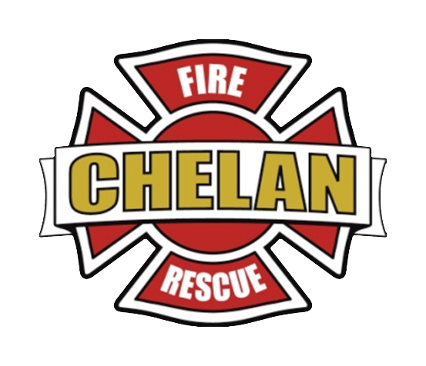

________________________________________________

2021 INCIDENT STATISTICS
________________________________________________

In 2021 Chelan Fire & Rescue responded to 1023 calls for emergency service which was an increase of 10.1% over our 2020 call volume. Even though the majority of our emergency responses were for rescue and emergency medical incidents, our calls for fire suppression average higher than most fire response agencies due to our Wildland Urban Interface. On August 14th, Chelan Fire & Rescue personnel were on the initial attack for the 25 Mile Fire that started on USFS land in the 25 Mile Creek drainage. This fire burned over 23,000 acres and was a season ending event.

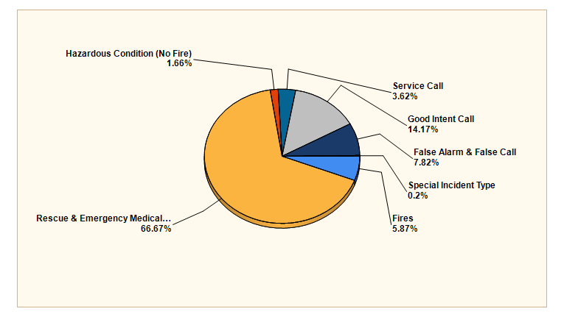
MAJOR INCIDENT TYPE | # INCIDENTS | % of TOTAL
Fires | 60 | 5.87%
Rescue & Emergency Medical Service | 682 | 66.67%
Hazardous Condition (No Fire) | 17 | 1.66%
Service Call | 37 | 3.62%
Good Intent Call | 144 | 14.17%
False Alarm & False Call | 80 | 7.82%
Special Incident Call | 2 | .20%
TOTAL | 1023 | 100.00%

2021 Incidents by Month
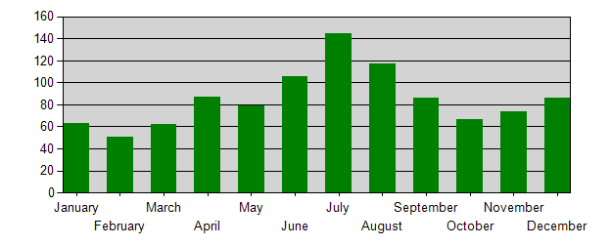

2021 Incidents by Day of Week
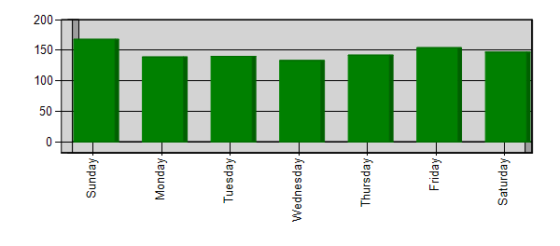
2021 Incidents by Hour of Day
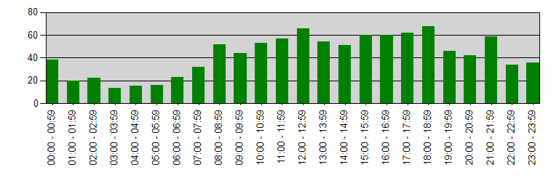

_______________________________________________

2021 turnout times and responses
________________________________________________

Chelan Fire & Rescue has established Response Time Standards that are outlined in Standard Operating Guideline (SOG) 010, Service Goals and Objectives. The service goals and objectives are adapted from NFPA 1710 and NFPA 1720 Standards for the Organization and Deployment of Fire Suppression. EMS, and Special Operations to the Public by Career and Volunteer Fire Departments.

Turnout (Reaction) Time is period of time when responders are notified by dispatch and the beginning of movement towards the emergency incident. Turnout Time Standards are identified in SOG 010, Service Goals and Objectives.

2021 Turnout Times by Station | Turnout Time (min)
71 - City of Chelan (2 minutes) | 3:49
72 - Chelan Falls (10 minutes) | 2:02
73 - Union Valley (10 minutes) | 3:26
74 - Howard Flats, Chelan Airport (10 minutes) | 3:05
75 - South Lakeshore (10 minutes) | 11:51
76 - North Shore (2 minutes) | 2:04
77 - Bear Mountain, Hawks Meadow, Pat & Mikes (2 minutes) | 2:01
CC - Chelan County (Mutual Aid Response) | 8:59
DC - Douglas County (Mutual Aid Response) | 9:13
Response Time is a combination of turnout time and travel time to the incident as
identified in SOG 010, Service Goals and Objectives, meaning that we are able to arrive on scene within 90% of emergency incidents.

2021 Response Times by Station | Response Time (Min)
71 - City of Chelan (5 minutes) | 7:35*
72 - Chelan Falls (10 minutes) | 8:59
73 - Union Valley (20 minutes) | 13:26
74 - Howard Flats, Chelan Airport (20 minutes) | 11:43
75 - South Lakeshore (22 minutes) | 19:54
76 - North Shore (15 minutes) | 11:24
77 - Bear Mountain, Hawks Meadow, Pat & Mikes (15 minutes) | 10:12
CC - Chelan County | 29:38
DC - Douglas County | 36:12

*Station 71 has 24/7 career personnel staffing with reserve members responding from home which impacts average turnout and response times. Career staff turnout and response times were consistently within the 90 Percentile Time Standard for 2021.

_______________________________________________

2021 effective work force
________________________________________________

The Effective Work Force is the number of personnel necessary to complete critical tasks as outlined for specific emergency responses. Those numbers are identified in SOG 010, Service Goals and Objectives, and are listed below. Effective Workforce numbers in BOLD met standard for 2021.

2020 Effective Work Force (Minimum) | Personnel
Emergency Medical Responses – BLS (2) | 2
Wildland Fire Responses (4) | 11
Residential Fire Responses – 1st Alarm (11) | 10
Residential Fire Responses – 2nd Alarm (17) | 11
Commercial Fire Responses – 1st Alarm (16) | 8
Commercial Fire Responses – 2nd Alarm (24) | 15
Vehicle Fires (4) | 3
Hazardous Materials Incidents (3) | 3
Technical Rescue – Low Angle & Water (5) | 5

_______________________________________________________________

2021 pre-fire property values VS. FIRE LOSS
________________________________________________________________

Pre-Fire Property Values Versus Fire Loss validates agency ability to respond quickly to safely and effectively prevent property loss. Any value loss has a direct impact on the economics of a community and our continued ability to provide emergency operations due to loss assessed property valuation.

INCIDENT # | PRE-INCIDENT VALUE | LOSSES | SAVED
2021-019 | $2,000.00 | $2,000.00 | $0.00
2021-041 | $633,000.00 | $20,000.00 | $613,000.00
2021-052 | $100.00 | $100.00 | $100.00
2021-137 | $43,000.00 | $43,000.00 | $0.00
2021-155 | $61,496.00 | $61,496.00 | $0.00
2021-388 | $1,500,000.00 | $100,000.00 | $1,400,000.00
2021-392 | $3,000.00 | $3,000.00 | $0.00
2021-653 | $526,108.00 | $526,108.00 | $0.00
2021-762 | $453,000.00 | $1,000.00 | $452,000.00
2021-857 | $164,622.00 | $164,622.00 | $0.00
2021-887 | $2,000.00 | $2,000.00 | $0.00
Totals | $3,388,326.00 | $923,326.00 | $2,465,000.00
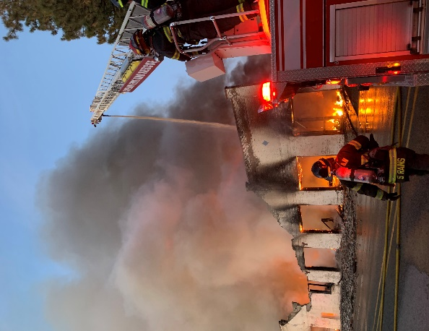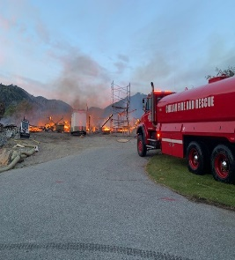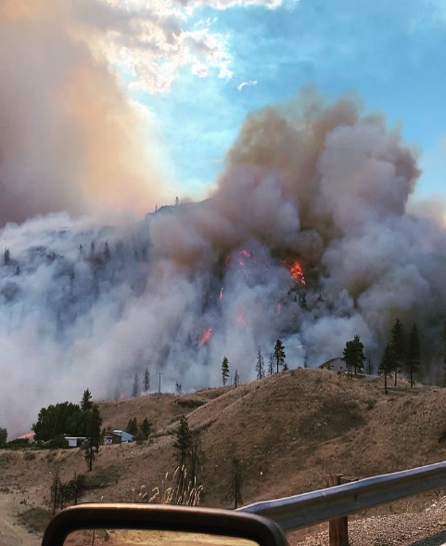

_______________________________________________

2021 PERSONNEL AND TRAINING
________________________________________________

Chelan Fire & Rescue was able to maintain adequate staffing throughout most of 2021 with sufficient volunteer, career, and support personnel to meet the mission of the organization. Our recruitment efforts were continually challenged during this pandemic period due to the infection control restrictions which impacted our ability to interact with our community. Despite these issues, Chelan Fire & Rescue was able to assist with the many mutual aid and state mobilization requests in addition to responding to 1023 call for emergency service in 2021

With the retirement of Chief Donnell at the end of 2021, the Board of Commissioners approved the contract for Assistant Chief Brandon Asher to take the reins as Fire Chief effective January 1, 2022. Chelan Fire & Rescue is currently recruiting for the Assistant Chief position with the individual selected starting in May 2022.

At the end of 2021, Chelan Fire & Rescue membership included:

- 3 Commissioners
- Administrative Office Manager
- Administrative Office Assistant
- Fire Mechanic
- Fire Chaplain
- Fire Chief
- Assistant Chief – Volunteer Recruitment & Retention (grant funded through 2021)
- 3 Career Fire Captain/EMTs
- 4 Career Firefighter/EMTs
- 35 Reserve Members (33 wildland qualified, 22 structure qualified, 6 certified EMTs)
- 3 Marine Operators

Keeping our members proficient with the skill sets necessary for safe and effective firefighting continued to be a challenge in 2021. Our members managed to accumulate over 4000 hours training through a combination of drill participation and online training to meet those annual requirements. Annual training included:

- Live Fire & Fire Suppression
- Initial and Annual Wildland Refresher Training
- Emergency Medical Training (Initial EMT course and on-going OTEP)
- Annual Rapid Entry Rescue Swimmer & Marine-71 Operator programs
- Technical Rescue – Low Angle Rope Rescue
- Hazmat Operations
- Annual EVIP and Driver/Operator Training
- Blue Card Incident Command

________________________________________________

2021 APPARATUS
________________________________________________

- We surplussed Support 71 and were able to place it in service as the regional Hazmat team response vehicle stationed in Wenatchee.

- We acquire a 2nd military surplus M-1083 at no cost through DNR Surplus Vehicle Acquisition Program and are converting it into a 2nd Type 3 Heavy Brush Truck with funding assistance through the DNR Phase 2 Grant program. This apparatus will give us another Type 3 Heavy Brush Truck with a service life of 10+ years, at a cost of $35,000.00 to the Fire District.

- We are replacing another chassis on one of our Type 6 Brush Trucks with an upgraded Dodge 5500 diesel chassis which will add another 10 years of service life as Brush 71.

- These acquisitions added a 4th structure Engine and 3rd Type 3 Heavy Brush Truck to upgrade our aging fleet with apparatus with a service life of 10+ years at a cost of $70,000.00.

- The corrosion work for Ladder-71, (2007 Pierce 75” Quint) which is being performed by Pierce will come in under budget with a return to service date of March 2022.

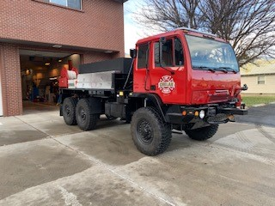
- With the successful passage of Proposition 1, we now have dedicated funding for future apparatus replacement. Staff developed an Apparatus Replacement Schedule and implemented a Apparatus Replacement Committee to determine immediate and future needs along with sustainable funding options.
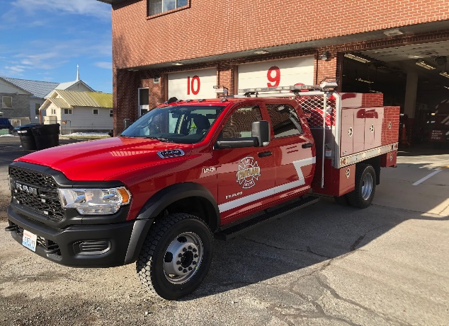

________________________________________________

2021 FACILITIES & CAPITAL PROJECTS
________________________________________________

Chelan Fire & Rescue completed several facility projects in addition to acquiring new and much needed equipment in 2021. Several projects slated for 2021 were moved into 2022 to ensure that funding was available with the passage of Proposition 1 in November 2021. With the increased revenue stream staff will be able to facilitate much needed facility updates and equipment needs identified in our Capital Replacement Schedule.

Facilities:
- Completed installation of emergency generator for Station 74 which was funded through Fire Mitigation Assistance Grant (FMAG) program.
- Replaced outdated lighting at Station 74 at no cost to the district. (Chelan PUD rebate program.)

Equipment:
- Replacement of hose and appliances necessary for fire suppression.
- Continued replacement of outdated Automated External Defibrillators.
- Replacement of structural and wildland personal protective gear.
- Replacement of radios and pagers.
- Purchase of new chainsaws
- Purchased two additional apparatus lifts for Fleet Manager that will allow for work on aerial apparatus and tenders.

____________________________________________________________

2021 CHELAN FIRE AND RESCUE HIGHLIGHTS
_____________________________________________________________

Strategic Planning & Budget:
- Proposition 1, Chelan Fire & Rescue proposal to increase levy lid lift to $1.10/$1,000.00 assessed valuation was successfully approved by the voters of the fire district. This increase in our annual operating revenue will allow Chelan Fire & Rescue to fund continued operation and necessary apparatus/capital replacement well into the future.
- 2021-2025 Strategic Plan Approved and Adopted by the Board of Commissioners.
- 2021 Budget (Year-end budget spent @ 100% of forecast with excess carry over funds of approximately $213,000.00 from state mobilizations)
- 2022 Budget Process completed and approved by the Board of Commissioners
- Successful 2020 State & Federal Audits

Operations and Incident Response:
- Continued Covid Pandemic response sponsoring 21 drive-thru vaccination clinics with Lake Chelan EMS.
- Assistant Chief Asher spent two weeks as IC for regional covid incident management team.
- 1023 responses for emergency service in 2021 (increase of 10.1% over last year)
- Participated in 7 Washington state mobilizations and 1 EMAC mobilization in Oregon.
- Major Incidents: 25 Mile Fire (August 14, 2021)
- Assisted on multiple 2nd and 3rd alarm fires in Chelan and Douglas Counties.
- Assistant Chief Asher promoted to Fire Chief effective January 1, 2022.
- Completed the process to become a Washington State Trauma Verified Agency.

Apparatus:
- Brush-74 Heavy (M-1083) build was completed and placed into service.
- Acquired a 2nd M-1083 through DNR Surplus Vehicle Acquisition Program and started rebuild into Brush-73 Heavy. Expected completion date is April 2022.
- Completed replacement of 1st Ford 550 Chassis with Dodge 5500 Crew Cab (R-71)
- Acquired 2nd Dodge 5500 Crew Cab for Brush-71 chassis replacement to be completed March 2022.

Facilities:
- Completed the installation of the emergency generator at Station 74 with funding secured through FMAG program.
- Replaced lighting at Station 74 with no cost to the district (Chelan PUD rebate program.)

Other:
- No injuries due to fire related incidents.
- Started work on 2022 Annexations
- 2020 Awards Banquet – August 2021

____________________________________________________________

2021 Chelan Firefighters Association
____________________________________________________________

The Chelan Firefighters Association is an integral part of our organization that focuses on benevolent efforts to our community. This incredible organization, comprised of current and former members as well in addition to members of the community, provides emergency funds for the victims of fires and accidents in their most desperate time of need. Through their annual fundraising efforts, they contribute to local food programs, sponsorships of community programs, support of our veterans at their annual parade, and ensuring that Parade 71 is out and about in the community. Their unselfish efforts of the Chelan Firefighters Association have provided our community with much need resources all in support of our mission.

Chelan Fire Fighters Association Accomplishments 2021:

- Created a new website: www.cd7ffa.com. Posted photographs of important CFR events, such as Station 73 Open House, Recognition Night, and the Christmas Holiday Celebration. Also maintained a regularly updated status page about the Twenty-Five Mile Fire, and created another page to document the live-fire training on November 20th.

- Volunteers helped with drive-through vaccinations at Station 71.

- Donated $2,500 to Chelan Food Bank, $500 of it for Thanksgiving Holiday Dinner

- Donated $1,000 to a family who lost their home in the 25 Mile Fire

- Together with Local 4816, helped put on the VFW Luncheon, and donated proceeds of $1,161 to VFW Post 6853.

- Participated in the Annual Veteran’s Day Parade.

- Purchased $400 worth of candy for distribution to children at Halloween.

- Purchased lights and decorated the Parade Truck and the Rescue Boat for the Christmas holidays.

- Maintained the Parade Truck and manned it during holiday parades such as Small-Town Holidays.

- Was awarded $1,200 by Washington Business Association which we passed along to Santa’s Stars.

- Contributed $500 to Salvation Army Virtual Kettle on behalf of Chelan Valley Hope.

2021 Budget and Financials

Chelan Fire & Rescue closed out 2021 with increased revenues, generated through state mobilization reimbursements, and deceased operating expenses that resulted in an increase in uncommitted funds. Our sound financial management practices along with annual state/federal audits demonstrate our commitment to financial stewardship of the funds we are entrusted.

2021 Budget 2021 Actual
Starting Fund: $ 513,869.00 $ 539,489.79
Tax Revenue: $2,204,971.00 $2,153,097.37
SAFER Grant; $ 227,129.00 $ 284.653.00
Other Revenue: $ 45,480.00 $ 169,231.37
Transfer In $ 0.00 $ 18,248.00
Sub-Total: $2,991,449.00 $3,172,831.62

Expenses: $2,084,058.00 $2,004,013.08
Transfer to Capital $ 277,129.00 $ 108,461.00
To General Reserve Investment $ 76,200.00 $ 76,200.00
To Capital Reserve Investment $ 0.00 $ 8,220.00
Transfer Out Bond $ 88,900.00 $ 88,900.00
Sub-Total $2,526,846.00 $2,312,277.00

Ending Balance: $ 464,603.00 $ 703,033.75

Desired Carry Over: $ 600,000.00 $ 600,000.00

Uncommitted Funds $ -135,397.00 $ 103,033.75

General Reserve Investment Fund
General Reserve Investments cover contingency expenses, meet seasonal cash flow shortages, and upgrade or maintain the Fire District’s credit rating. The 2022 budgets allocates $76,200.00 annually to this account which will bring the District into compliance with our internal financial policies.

2021 Year End Account Balance $632,859.02 ($38,100.00 January 2022)

Capital Reserve Investment Fund
The Capital Reserve Investments are funds allocated for apparatus replacement and capital expenses. Funds from this account were used for apparatus replacement that is identified under the 2020 Apparatus section and Capital Projects identified in our 2020 Budget. This account is funded through reimbursements received from state mobilizations, sales of surplus apparatus and equipment, and any uncommitted funds at year end as approved by the Board of Commissioners.
2021 Year End Account Balance $206,162.70
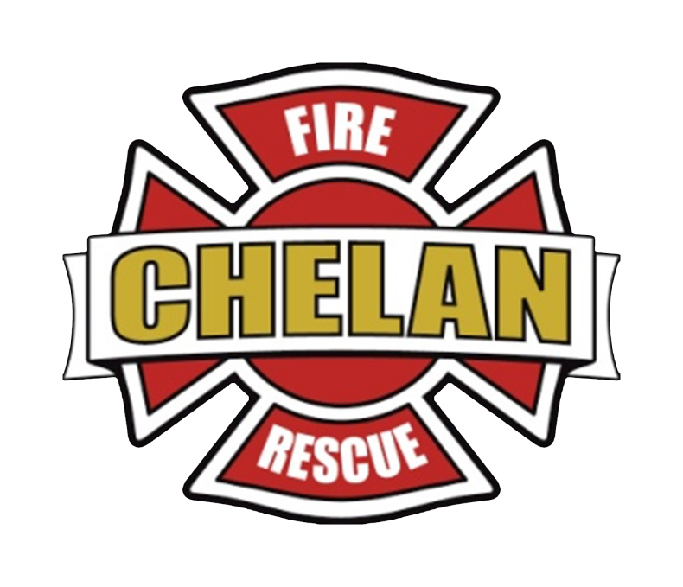

Chelan Fire, Rescue & EMS
Administration Office
232 E. Wapato Ave.
PO BOX 1317
Chelan, WA, 98816

Mark Donnell
Fire Chief
mdonnell@cfr7.org

Brandon Asher
Assistant Fire Chief/Volunteer Coordinator
basher@cfr7.org

Carol Kibler
Administrative Office Manager
carolk@cfr7.org
Website: Chelan7.com

